**Products App Guide**

Step 1:

Visit the URL: <https://github.com/thirunavukkarasu-s/zaportiv>

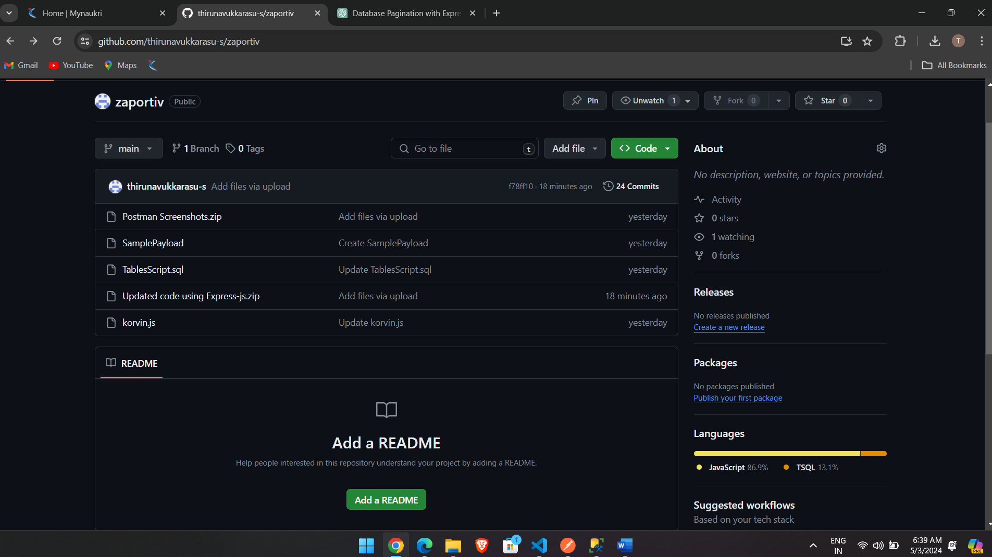

Step 2:

Download the file name “Updated code using Express-js” and decompress it. You can find two folders:

1. Products
2. DB backup

Step 3:

Configure “products” app in VS Code and install the dependencies in package.json.

Step 4:

Restore DB backup file name “ProductCatalogDB.bak” in MS SQL Server management studio.

Step 5:

Update DB connection properties as per your environment in config.js.

Step 6:

Run the command “npm run start” in terminal

Step 7:

Open POSTMAN app

Use this URL: <http://localhost:3000/login> - POST method

Payload: { "username": "thiru", "password": "pwd" }

You can get token as shown in this screenshot

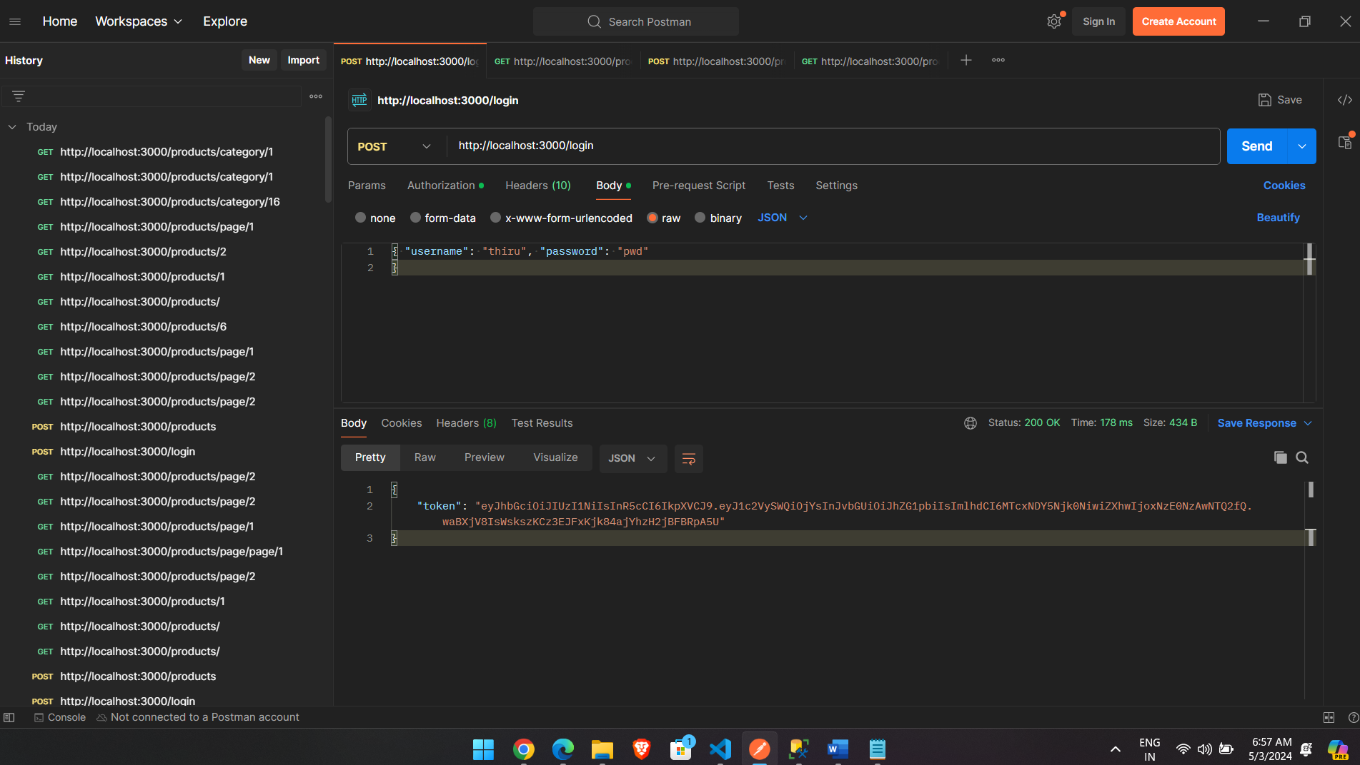

Step 8:

Using this authorization token, you can check following URLs

Create product: <http://localhost:3000/products> - POST method

Payload:

{

"name": "LED Light",

"code": "LED",

"description": "LED Light",

"categoryId": 2,

"price": 200,

"availability": 400

}

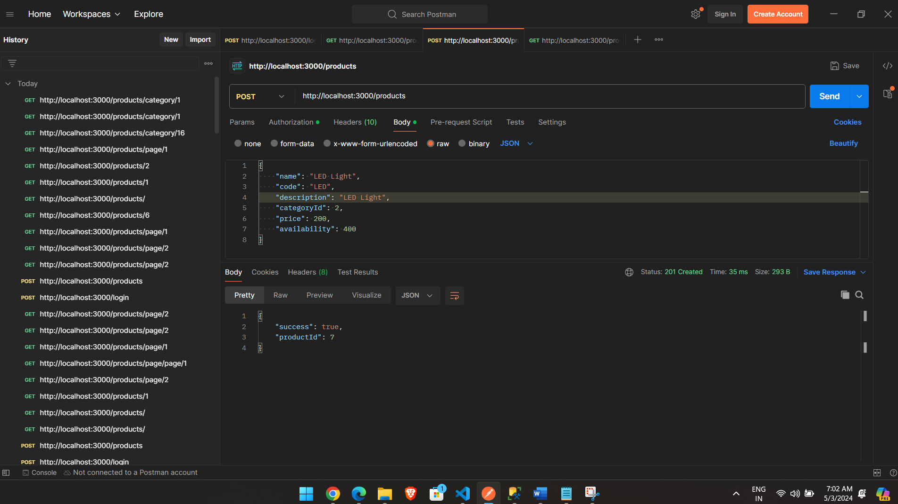

<http://localhost:3000/products/> - GET method

<http://localhost:3000/products/2> - GET method

<http://localhost:3000/products/page/1> - GET method

<http://localhost:3000/products/category/1> - GET method